TO THE HISTORY OF THE POSTMARK OF THE REPUBLIC OF KAZAKHSTAN No. 499, DEDICATED TO THE ANNIVERSARY OF KazSRVI

A postage stamp dedicated to research institutes is extremely rare in the world.
The reason for this is the small number of research centers that have a long uninterrupted history and crossed their centennial milestone at the beginning of the XXI century. The careful attitude of the national government and the scientific community to such a cultural event plays a major role.
In the late 19th and early 20th centuries, government scientific institutions in many countries of the world were mainly connected with veterinary, zootechnics, medicine and agronomy.
The first postage stamp known to us, associated with the anniversary of the Research Institute, is a postage stamp of Argentina dated September 11, 2004, with nominal 75 centavos, dedicated to the 100th anniversary of the founding of the Institute of Agronomy and Veterinary Science at the University of Buenos Aires.
4 months after this event, on January 14, 2005 there was a ceremonial issuance of postage stamp of Kazakhstan № 499, dedicated to the 100th anniversary of the founding of the Kazakh Scientific-Research Veterinary Institute (KazSRVI).
The postal miniature was issued in an edition of more than 1 million pieces, with a face value of 7 tenge (Figures 1-6)

Figure 1. Full stamp sheet (printed on the RSE "Banknote Factory of the National Bank of the Republic of Kazakhstan")

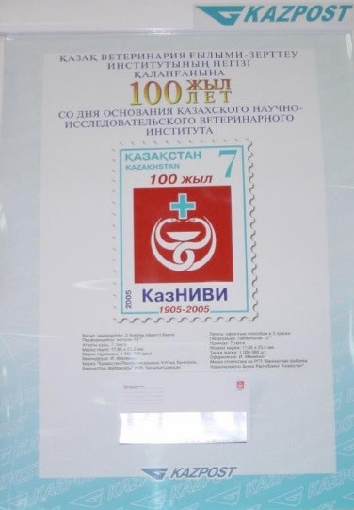

Figure 2. Advertising poster for the presentation of the postage stamp of the Republic of Kazakhstan No. 499

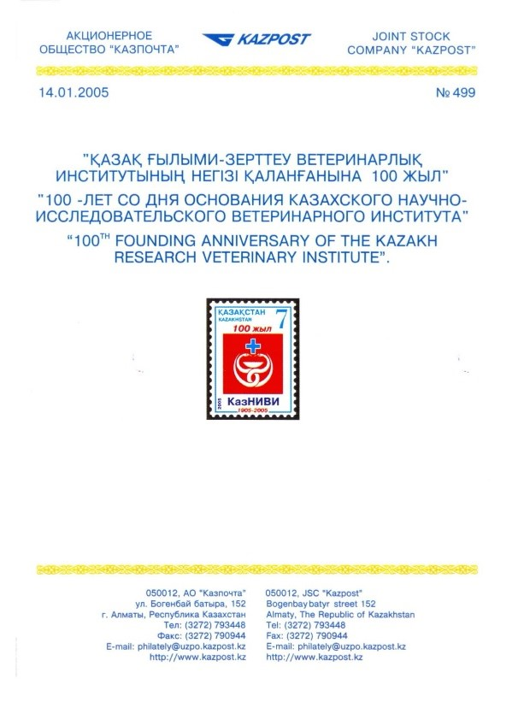

Figure 3. Press release for the postage stamp of the Republic of Kazakhstan No. 499

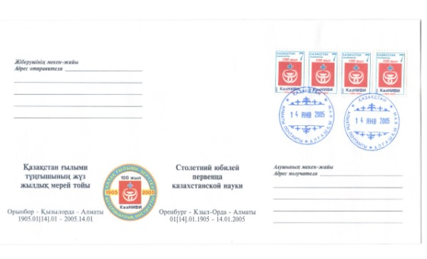

Figure 4. Unmarked commemorative envelope (500 copies in circulation)

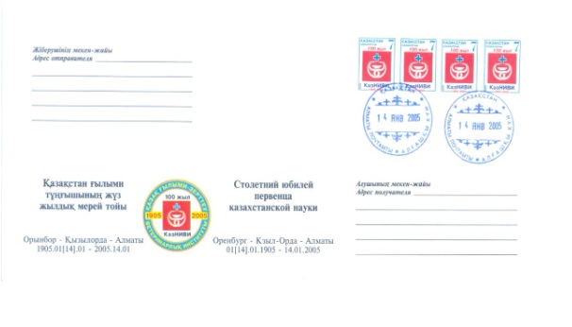

Figure 5. Envelope of the first day

Figure 6. Postage stamps of the Republic of Kazakhstan for 2005 (information sheet)

