TO THE HISTORY OF THE POSTAGE STAMP OF THE REPUBLIC OF KAZAKHSTAN No. 920, DEDICATED TO THE ANNIVERSARY OF VACCINATION AND PROPHYLAXIS
After studying the literary, archival and archaeological information about the material culture of the Turkic peoples in ancient times, we graphically reconstructed the emblems of medicine and veterinary medicine of the Turkic world on the example of the traditional Kazakh society.
Preliminary we have graphically reconstructed the basic elements of emblems, it was two fires of bright red color, located above each other and on one vertical line, each of which was framed by a colored arc.
In 2015, the republic was planning the 100th anniversary of vaccination in Kazakhstan. In connection with the upcoming anniversary date, on our initiative, the Ministry of Health of the Republic of Kazakhstan on June 18, 2013 appealed to the Ministry of Transport and Communications of the Republic of Kazakhstan with a letter and a mock-up of the future postage stamp for issue, which depicted the main elements of the emblem in the form of two lights with arcs, between which stood the inscription in the state language "KAZAKSTANDAGI VACCINOPROPHYLACTICAGA 100 ZHYL". In turn, the Ministry of Transport and Communications of the Republic of Kazakhstan addressed letter No. 03-16/ZHT-M-374-I dated November 25, 2013 to Kazpost JSC with a request to include one of the first issues of the named jubilee postage stamp in the 2015 plan. On January 15, 2015, a solemn cancellation of the postage stamp of the Republic of Kazakhstan No. 920 was held in Almaty, dedicated to the 100th anniversary of vaccination in Kazakhstan.
In 2015, the 100th anniversary of vaccine prophylaxis in Kazakhstan was to be celebrated. In connection with the upcoming anniversary date, on our initiative, the Ministry of Health of the Republic of Kazakhstan on June 18, 2013 addressed the Ministry of Transport and Communications of the Republic of Kazakhstan with a letter and a layout of the future postage stamp for issue, which depicted the main elements of the emblem in the form of two lights with arcs, between which stood the inscription in the state language " KAZAKHSTANDAGY VACCINOPROPHYLACTICAGA 100 ZHYL". In turn, the Ministry of Transport and Communications of the Republic of Kazakhstan addressed with the letter № 03-16/ZhT-M-374-I from November 25, 2013 to JSC "Kazpost" with a request to include one of the first in the plan of 2015 the issue of the named anniversary postage stamp. On January 15, 2015 there was a solemn stamping of the postage stamp of the Republic of Kazakhstan № 920 in the city of Almaty, dedicated to the 100th anniversary of vaccine prophylaxis in Kazakhstan.

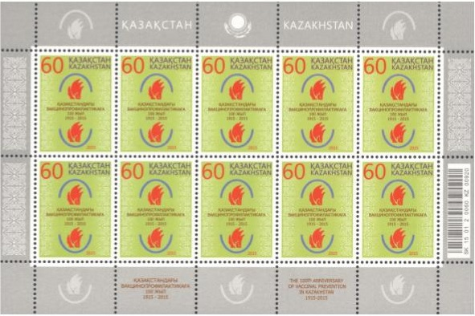

Figure 1. Full stamp sheet (printed in RUE "Bobruisk enlarged printing house named after A.T.Nepogodin" of the Republic of Belarus)

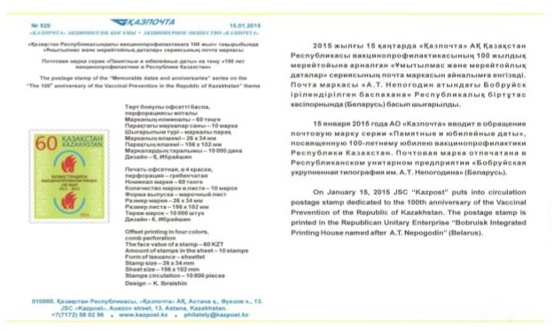

Figure 2. Press release to the postage stamp of the Republic of Kazakhstan No. 920

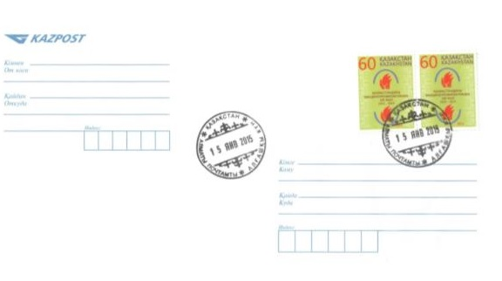
Figure 3. The envelope of the first day

