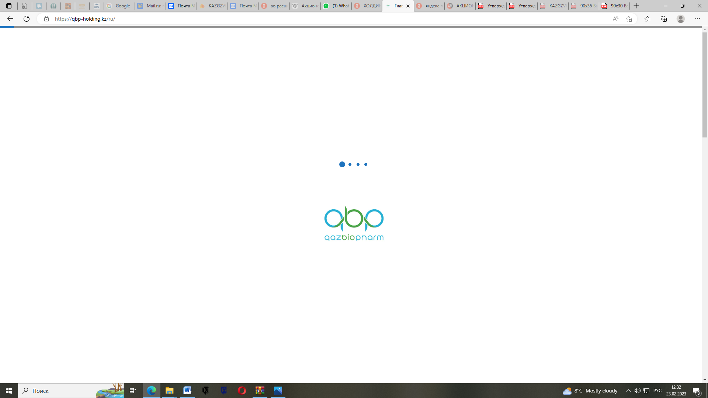

**MINISTRY OF HEALTHCARE OF THE REPUBLIC OF KAZAKHSTANJSC «NATIONAL HOLDING «QAZBIOPHARM»»**

**LLP «KAZAKH** **SCIENTIFIC RESEARCH VETERINARY INSTITUTE»**

**INFORMATION LETTER**

**Dear colleagues!**

“Kazakh Scientific Research Veterinary Institute” LLP - the first-born of Kazakhstani science, founded on the basis of veterinary-bacteriological laboratory, organized on January 14, 1905 in Orenburg, where the beginning of scientific research in the field of veterinary medicine was laid, invites you to take part in the International Scientific and Practical Conference **“Integration of science and practice in ensuring biological safety”,** **dedicated to the 120th anniversary of the Institute,** which will be held **on May 15-16, 2025** in Almaty, Republic of Kazakhstan.

To register, you must complete the registration form (Appendix 1) and send it electronically to the following email addresses: [sarbakanova_sholpan@mail.kz](mailto:sarbakanova_sholpan@mail.kz), [g_sarsenova_t@mail.kz](mailto:g_sarsenova_t@mail.kz).

The conference program will be posted on the website: qaznivi.kz.

**Venue** of the International Scientific and Practical Conference:Almaty city, Timiryazev Street 42, Atakent Park Hotel «Best Western Plus», «Grand Hall» Conference Room.

**The conference will be held in the following sections**:

**Section 1.** Actual issues of diagnostics, prevention and treatment of infectious, invasive and non-contagious diseases of animals.

**Section 2.** Biotechnological innovations in the field of biological safety: from research to commercialization.

**Section 3.** Molecular biology and genomics of microorganisms: ensuring biological and food safety.

**Section 4.** Interdisciplinary approaches in veterinary science: experience and perspectives.

Conference working languages: *Kazakh, Russian, English*.

Form of participation in the conference: *oral presentation, poster presentation, paper publication only.*

**Participation Terms:**

Materials for publication (Appendix 2) should be submitted to the organizing committee of the conference before March 25, 2025 in electronic form to e-mail g_sarsenova_t@mail.kz, fatimseme@mail.kz.

**Participation in the conference and article publication is free of charge.**

Dear authors, by submitting your materials for publication in the conference proceedings and completing the registration form, you consent to the processing of personal data and the publication of your materials in the conference proceedings.

Non-local participants must arrange their own hotel accommodations, provide their arrival/departure dates, and a contact phone number. Please arrange return tickets in advance. Travel and accommodation expenses for conference participants are covered by the sending party.

The conference organizers reserve the right not to consider manuscripts submitted in the wrong format or after the end of the proceedings.

The conference materials will be published in the Proceedings of the conference (electronic version) in various directions in Kazakh or Russian or English languages.

A competition for the best scientific work of young scientists will be held within the framework of the conference. The best works will be rewarded with diplomas and memorable awards.

The work of the conference will be accompanied by an exhibition of commercial companies-sponsors.

**For all inquiries, please contact the conference organizing committee:**

Nurpeisova Ainur Sultanovna, tel.: + 7 701 811 3427, e-mail: [ainurnurpeisova@mail.kz](mailto:ainurnurpeisova@mail.kz)

Tlegenova Zhuldiz Zhenisovna, tel.: +7 771 458 2496, e-mail: [zhenisova@mail.kz](mailto:zhenisova@mail.kz)

Sarsenova Gulzhausar Talgatkyzy, tel.: +7 778 552 1224, e-mail: [g_sarsenova_t@mail.kz](mailto:g_sarsenova_t@mail.kz).

Sarbakanova Sholpan Taupikovna, tel.: + 7 705 150 9520 e-mail: [sarbakanova_sholpan@mail.kz](mailto:sarbakanova_sholpan@mail.kz)

Perizat Akshalova, tel.: + 7 777 312 83 65, e-mail: [perizat.akshalova@mail.kz](mailto:Perizat.akshalova@mail.kz)

Appendix 1

**PARTICIPANT REGISTRATION FORM**

(to be completed for each participant)

For the International Scientific and Practical Conference

**«Integration of Science and Practice in Ensuring Biological Safety »**

|  |  |
| --- | --- |
| Full name |  |
| Institution |  |
| Academic degree and academic title |  |
| Position |  |
| Contact phone numbers: |  |
| E-mail |  |
| Form of participation (leave blank) | Oral presentation, poster presentation, publication only |
| Title of report, article |  |
| Direction |  |
| Language of the report |  |

Appendix 2

**Article format requirements**

1. UDC Index (Universal Decimal Classification) – placed in the top left corner of the first page. Leave one blank line after it.

2. Title. The article title should be concise (no more than 10 words). It must be typed in bold uppercase letters, font size 14, centered, single line spacing.

3. Authors’ initials and surnames – listed for all authors, separated by commas, in bold font size 12, centered, single line spacing.

4. Academic degree, position, full name of the institution (place of work), city, country, and email – centered, single line spacing, font size 12.

5. Leave one blank line after the author details. The abstract (no more than 800 characters) must be in italics, font size 12, with an indent of 1.25 cm.

6. Keywords (no more than 5) in italics, font size 12, with an indent of 1.25 cm. Leave one blank line after the keywords.

7. Main text of article should be prepared on A4-sized paper (210×297 mm) in Times New Roman, font size 12, single line spacing, with the following margins: left – 3 cm, right – 1.5 cm, top and bottom – 2 cm. Paragraph indent should be 1.25 cm; orientation must be portrait. Avoid hyphenation, headers, footers, and page numbers. Align text to width. Avoid forced hyphenation, and separate words in a paragraph with only a single space. Do not use spaces for alignment. Ensure no page or section breaks. Mathematical equations and chemical formulas should be created using the Equation Editor (MathType) or MS Word as a single object. Chemical formulas should use font size 9, and mathematical equations font size 10. Formulas and equations must be placed on a new line and numbered in parentheses at the end of the line. The article length must not exceed 5 pages.

8. Figures must be submitted in *.jpg format with references in the text. Captions should include the figure number and title (e.g., Fig. 1. …). Graphs, charts, and other visuals are recommended to be prepared in MS Excel or MS Graph. Tables should have titles and sequential numbers (e.g., Table 1) and must be referenced in the text. Figure captions (in bold italic font, size 10) should be centered on the page, with no period at the end.

9. The reference list must be in order of citation in the text. Use an indent of 1.25 cm.

10. Leave 1.5 line spacing after the reference list and provide the following information in English: article title, authors’ initials and surnames, full institution name (place of work/study), city, country, and email, abstract, keywords.

The article must include the following sections: introduction, which highlights the relevance and purpose of the research; materials and methods; results and discussion; conclusion; references to figures and tables must be provided within the text.

An expert opinion confirming the possibility of publication must be attached to the article.

The editorial board reserves the right to reject articles that do not comply with the requirements or contain numerous errors.

Authors are responsible for the accuracy and scientific editing of the submitted materials. Articles submitted after the deadline will not be included in the proceedings.

Example of design

UDC 595.421

**TICKS OF THE GENUS *HAEMAPHYSALIS KOCH*, 1844 (IXODIDAE, AMBLYOMMINAE) IN THE KYZYLORDA REGION**

Z.Z. Sayakova

Academic degree, position

Name of place of work

City, country, e-mail

**Annotation.** Annotation.

**Keywords:** Keywords.

Text of the article

List of references

1. Atshabar B.B. Passport of Kazakhstan regions on especially dangerous infections // Quarantine and zoonotic infections in Kazakhstan. – 2015. - №1(31). – 179 p.

2. Umirzakhova А. To the fauna of ixodid ticks (Acariformes, Ixodoidea) of the Shieli district of the Kyzylorda region // Bulletin of KazNU named after Al-Farabi. Ecological series.-2015.- 2/2(44). – P. 775-777.

We look forward to your participation!

The Organizing Committee will be grateful for the distribution of this letter among interested parties!

Sincerely, Conference Organizing Committee!