**International Scientific and Practical Conference**

**«Integration of science and practice in ensuring biological safety» dedicated to the 120th anniversary of the Kazakh Scientific Research Veterinary Institute.**

**Kazakh Scientific Research Veterinary Institute**

**(May 15-16, 2025)**

LLP «Kazakh Scientific Research Veterinary Institute» holds the International Scientific and Practical Conference «**Integration of Science and Practice in Ensuring Biological Safety**» dedicated to the 120th anniversary of the Institute, which will be held **on May 15-16, 2025 in Almaty, Republic of Kazakhstan**

The aim of the Conference is to strengthen the interaction between science and practice in the field of veterinary medicine through the exchange of international experience, integration of innovative technologies and development of strategic directions to ensure biosecurity.

The Conference is expected to be attended by 200-250 delegates, representatives of the Presidential Administration, Ministry of Health, Ministry of Agriculture, Ministry of Science and Higher Education, international and domestic research institutes and institutions, young scientists - researchers, veterinary specialists, biologists and others.

At the end of the event, a final informational and analytical report will be prepared and presented to a wide range of interested organizations, along with the electronic publication of the conference proceedings.

# DATE AND VENUE

**15 May 2025 -** Plenary, breakout sessions

**16 May 2025** - Continuation of the work of the sections, closing session.

**Venue: Atakent Park Hotel «Best Western Plus»**

Address: Timiryazeva str. 42 K.10

Website: <https://aphotel.kz/>

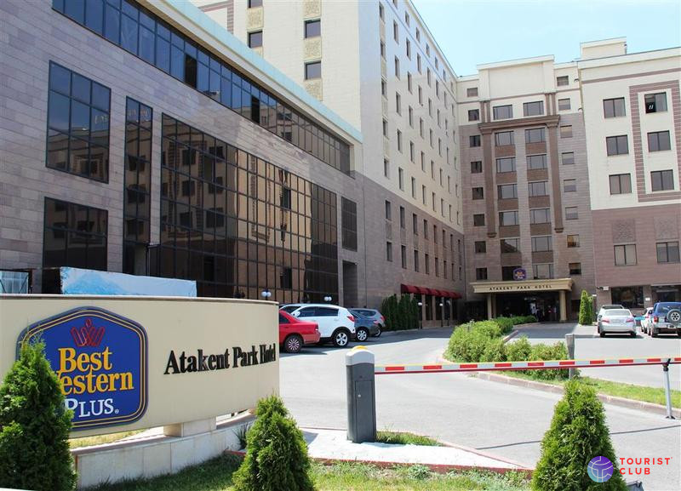

**PROGRAM**

# International Scientific and Practical Conference

# «Integration of Science and Practice in Ensuring Biological Safety»

# dedicated to the 120th anniversary of the Kazakh Scientific Research Veterinary Institute

# (May 15-16)

|  |  |  |
| --- | --- | --- |
| **Thursday, May 15, 2025** | | |
| 09:00 – 10:00 | **Registration of participants/coffee break** |
| 10:00 – 10:05 | **Forum opening** |
| 10:05 – 10:30 | **Welcome speech:**   1. **Zakaryia Kunsulu Daltonovna,** *Advisor to the President of the Republic of Kazakhstan on Science and Innovation* 2. **Dossaev Yerbolat Askarbekovich,** *Akim of Almaty* 3. **Alnazarova Akmaral Sharipbaevna,** *Minister of Health of the RK* 4. **Saparov Aidarbek Seipellovich,** *Minister of Agriculture of the RK* 5. **Sayasat Nurbek,** *Minister of Science and Higher Education of the RK* 6. **Bakkhozhayev Anas Akhatovich,** *Deputy of the Mazhilis Parliament of the Republic of Kazakhstan* 7. **Yegizbayev Serik Rakhmetollauly,** *Deputy of the Mazhilis of the Parliament of the Republic of Kazakhstan, Chairman of the PDPP "Aul"* 8. **Kurishbayev Akhylbek Kazhigulovich,** *President of Board of the National Academy of Sciences under the President of the Republic of Kazakhstan* 9. **Yespolov Tlektes Issabayevich,** *President of the Academy of Agricultural Sciences of the RK* 10. **Taytubayev Mereke Kusainovich,** *Head of the Subregional Coordination Office of the World Organization for Animal Health (WOAH) on Foot-and-Mouth Disease in Astana* 11. **Tashimov Kazbek Kazikhanovich,** *Chairman of the Veterinary Control and Supervision Committee of the Ministry of Agriculture of the RK* 12. **Abduraimov Yergali Orynbasarovich,** *General Director of JSC National Holding «QazBioPharm»* 13. **Sansyzbay Abylay Rysbayuly,** *Director of KazSRVI**(1997-2007)* 14. **Batyrkhanov Markhabat Serikbaevich**, *Director of KazSRVI**(2008-2010)* 15. **Sultanov Akhmetzhan Akievich**, *Director of KazSRVI**(2010-2022)* |
| 10:30 – 11:15 | **Plenary Session**  *Moderators: Abduraimov Y.O., General Director of JSC National Holding «QazBioPharm»*  *Kassenov M.M., General Director of LLP «KazSRVI»* |
| 11:15 – 11:45 | Coffee-break |
| 11:45 – 13:00 | **Plenary Session**  *Moderators: Abduraimov Y.O., General Director of JSC National Holding «QazBioPharm»,*  *Kassenov M.M., General Director of LLP «KazSRVI»* |
| 13:00 – 14:30 | Lunch |
| 14:30 – 17:00 | **Working Sections**  **Section 1 -** Actual issues of diagnostics, prophylaxis and treatment of infectious, invasive and non-infectious diseases of animals  *Moderator: Abdybekova A.M., Doctor of Veterinary Sciences, Professor*  **Section 2 –** Biotechnological Innovations in Biological Safety: From Research to Commercialization  *Moderator: Nurpeisova A.S., Ph.D.*  **Section 3 –** *Molecular Biology and Genomics of Microorganisms: Ensuring Biological and Food Safety*  *Moderator: Akshalova P.B., Candidate of Veterinary Sciences*  **Section 4 –** *Interdisciplinary Approaches in Veterinary Science: Experience and Prospects*  *Moderator: Baramova Sh.A., Doctor of Biological Sciences, Professor* |
| **18:00** | **Gala dinner** |
| **Friday, May 16, 2025** | | |
| 09:00 – 10:00 | **Coffee-break** | |
| 10:00 – 12:00 | **Continuation of section activities**  **Section 1 -** Actual issues of diagnostics, prophylaxis and treatment of infectious, invasive and non-infectious diseases of animals  *Moderator: Abdybekova A.M., Doctor of Veterinary Sciences, Professor*  **Section 2 –** Biotechnological Innovations in Biological Safety: From Research to Commercialization  *Moderator: Nurpeisova A.S., Ph.D.*  **Section 3 –** *Molecular Biology and Genomics of Microorganisms: Ensuring Biological and Food Safety*  *Moderator: Akshalova P.B., Candidate of Veterinary Sciences*  **Section 4 –** *Interdisciplinary Approaches in Veterinary Science: Experience and Prospects*  *Moderator: Baramova Sh.A., Doctor of Biological Sciences, Professor* |
| 11:15 – 11:45 | Coffee-break |
| 12:00 – 12:05 | **Closing session**  *Speaker: Kassenov Marhabat Melisbekovich, General Director of «Kazakh Scientific Research Veterinary Institute» LLP* |
| 12:05 – 12:15 | **Adoption of the resolution of the International Scientific and Practical Conference «Integration of Science and Practice in ensuring biological Safety»** |
| 12:15 – 12:45  12:45 – 13:00 | **Presentation of «Algys Hat»** **certificates to the speakers and sponsors of the International Scientific and Practical Conference «Integration of Science and Practice in ensuring biological Safety»**  **Closing ceremony of the conference** |
| 13:00 – 14:30 | **Lunch** |
| 16:00 – 20:00 | **Cultural program for foreign guests** |
| 15:00 – 17:00 | **Veterans of the Institute visit KazSRVI** |

# INFORMATION ABOUT THE COUNTRY

**Currency and card payment**

The currency of Kazakhstan is tenge (KZT). Payments in the territory of the Republic of Kazakhstan are made in the form of cash and non-cash payments. Foreign currency exchange is carried out by banks and exchange offices, which can be easily found in the city.

**Weather and clothing**

In May, the climate in Almaty can be described as warm. The average daytime temperature is 24 C. In Almaty, 10 clear, 9 rainy, 9 with variable clouds and 3 cloudy days are expected in May. The rains are mostly moderate. The weather can change frequently, so we recommend that you bring warm clothes and an umbrella. A detailed weather forecast for Almaty is available on the website <https://yandex.kz/pogoda/almaty/month/may?lat=43.273564&lon=76.914851>.

**Electricity**

The power supply parameters are 220V and 50Hz. Sockets used in Kazakhstan use standard European two-pin plugs..

**Local time**

Astana Time is in effect in Almaty (AST – CET+4, CEST+3, UTC+5). All times in the program are given in AST.

# HOTEL ACCOMMODATION

Delegations are kindly requested to book a room at the Best Western Plus Atakent Park Hotel in advance. When booking a hotel, it is necessary to indicate in the letter the First name, Last name, phone number, number of nights of stay, the name of the event (International Scientific and Practical Conference **"Integration of science and practice in ensuring biological safety"**).

Please note:

• The special room rate applies only for the period from May 14 to May 16.

|  |  |  |  |
| --- | --- | --- | --- |
|  | **The cost of a single room (standard)** | **The cost of a double room (standard)** | **The cost of a luxury room** |
| *Best Western Plus Atakent Park Hotel* (4*)  Timiryazeva str. 42 K.10  050057, Almaty, Kazakhstan  Tel.: +7 727 355 42 42 | 24/7  Email address: [sales@aphotel.kz](mailto:sales@aphotel.kz)  Website <https://aphotel.kz/> | 55 000 KZT | 63 000 KZT | 65 000 KZT |
| The hotel is located on the territory of the Atakent Kazakhstan Business Cooperation Center in Almaty, where various international exhibitions are regularly held.  The hotel's rooms are decorated in a classic style and equipped with everything necessary for comfort on a business trip.  The on-site restaurant serves international cuisine, a lobby bar, a fitness center and a souvenir shop.  The nearby Botanical Garden and the spacious Atakenta territory contribute to outdoor recreation. Within walking distance there are shopping malls "Atakent Mall" and "Student" with a wide range of shops and entertainment. The bus routes that run nearby cover all areas of the city.  The attentive staff is always ready to help you make your stay as comfortable and profitable as possible. | | | |

*\** ***Note - Detailed information on accommodation and hotel conditions will be specified closer to the date of the conference.***

**Cultural Program (Сontribution: 40 $ / person)**

On May 16 after the conference we offer a cultural program for foreign guests with an excursion to Kok-Tobe, including dinner in the restaurant of national Kazakh cuisine. This is a wonderful opportunity to enjoy the picturesque scenery and learn more about the culture of our country.

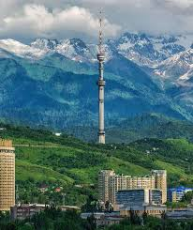

**«Kok-Tobe»** is a hill located in the southeastern part of Almaty. The height is 1130 meters above sea level. You can climb Kok-Tobe either by serpentine road or by cable car, which starts from the square near the Palace of the Republic (Dostyk Ave., corner of Abay Ave.). The length of the ropeway is 1727 meters, travel time is 6 - 7 minutes, during which you can watch the beautiful green landscape of the city below, where the boundless city high-rises stretch. In 2006, the entertainment center «Park Kok Tobe» was opened on the mountain. The upper station of the cable car is located on the territory of Kok Tobe Park. On the slope of Kok Tobe Mountain there is the famous 372-meter Almaty Television Tower - one of the peculiar symbols of the city and its tallest structure

**Website:** <https://koktobe.com/>